**HILLEL ACADEMY HIGH**

**MATHEMATICS DEPARTMENT**

**Distributive Property**

**NAME: ______________________ DATE: _________**

**Complete the following showing all work!**

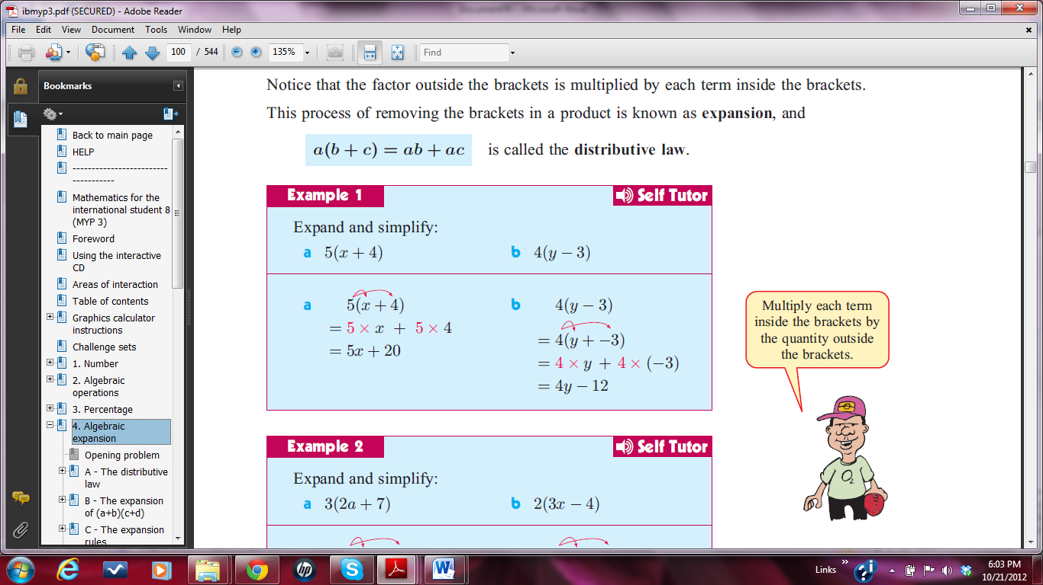

**Section 1:**

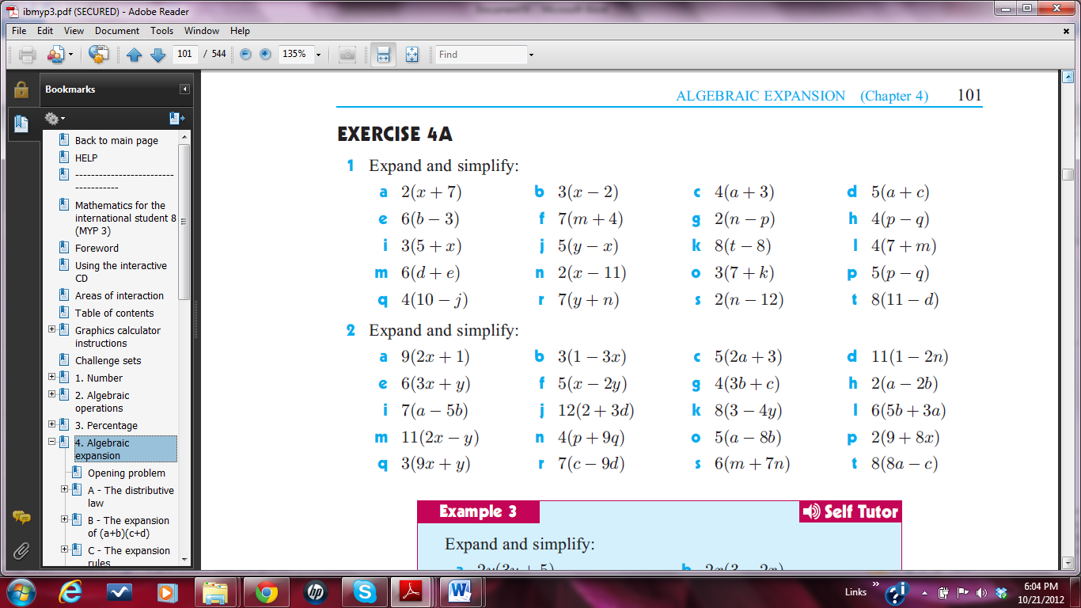

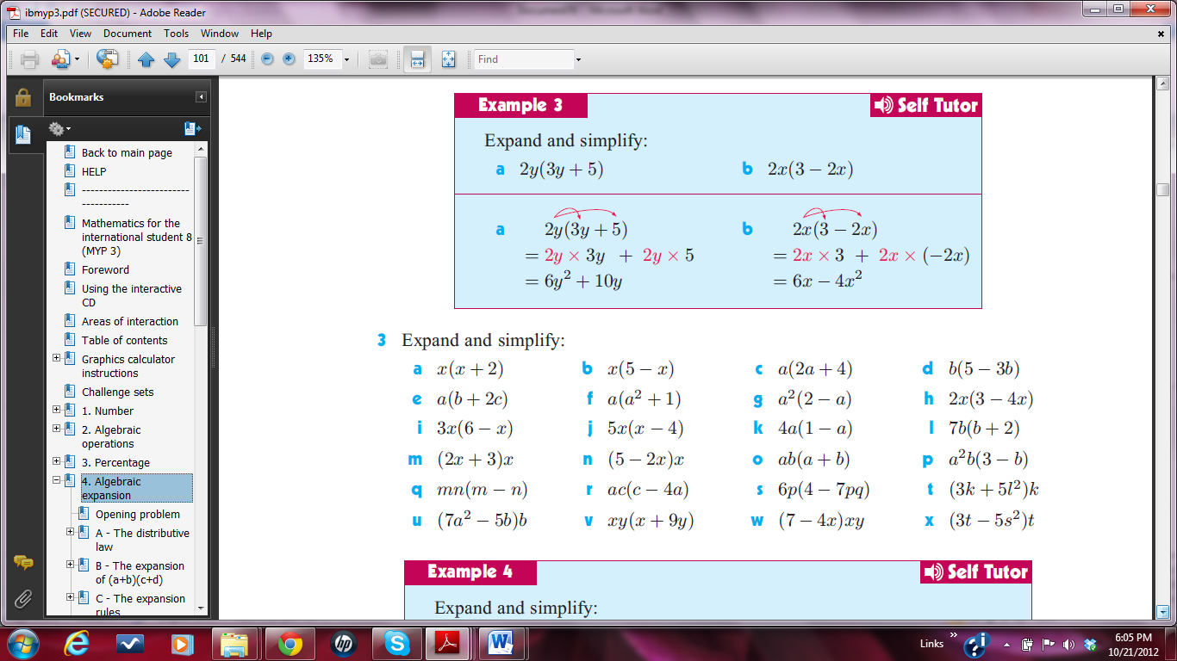

**Section 2:**



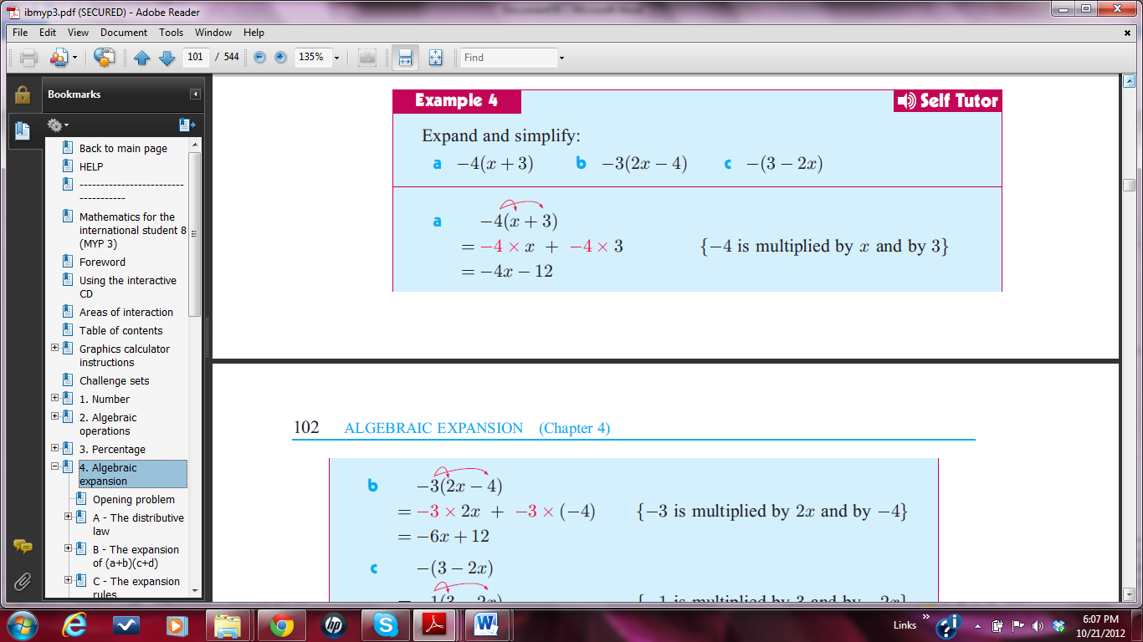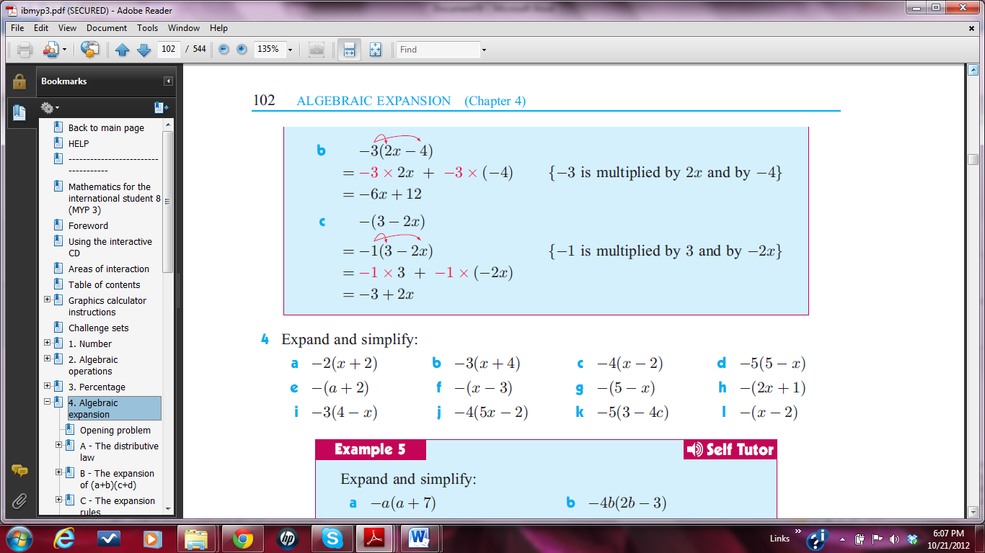

**Section 3:**



**Section 4:**

