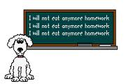
WORKSHEET – LEVEL 7
TOPIC: EQUATIONS LINEAR APPLICATION QUESTIONS

NAME: ___________________________________ DATE: ______________
SECTION 1: GEOMETRY -

