Percent: Review Packet

NAME: _________________________________________ DATE: ____________

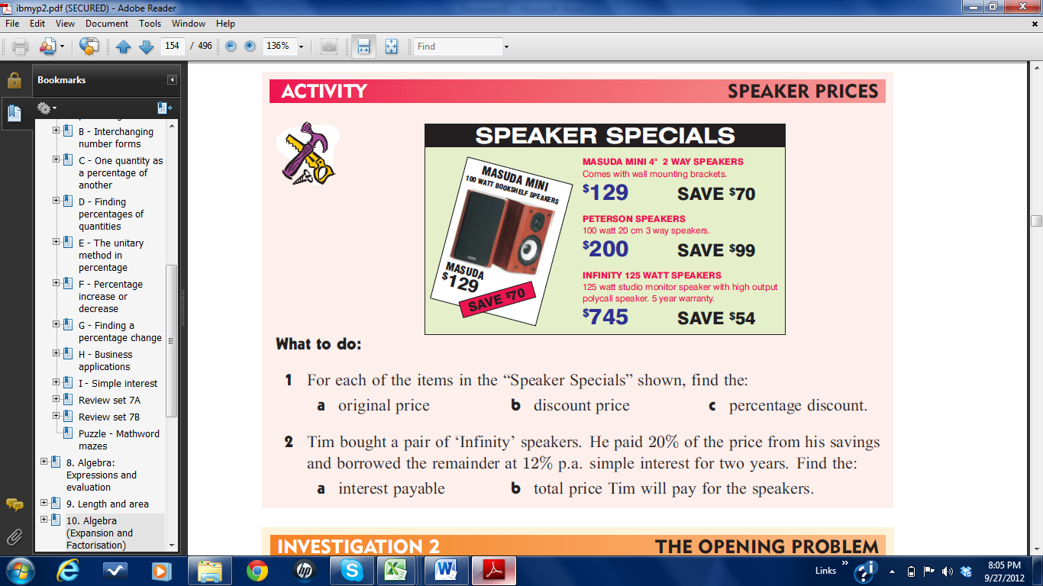

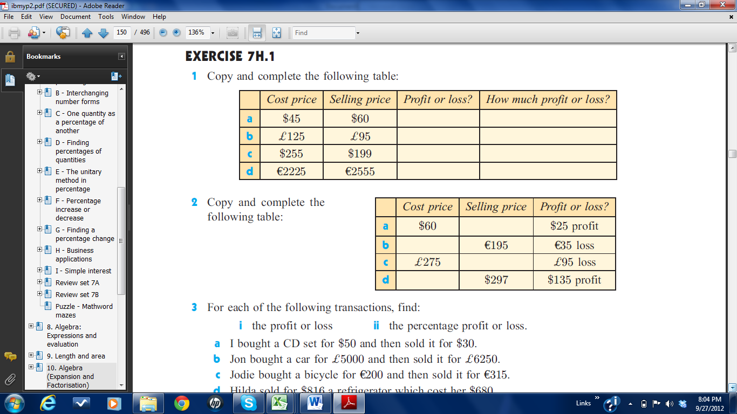

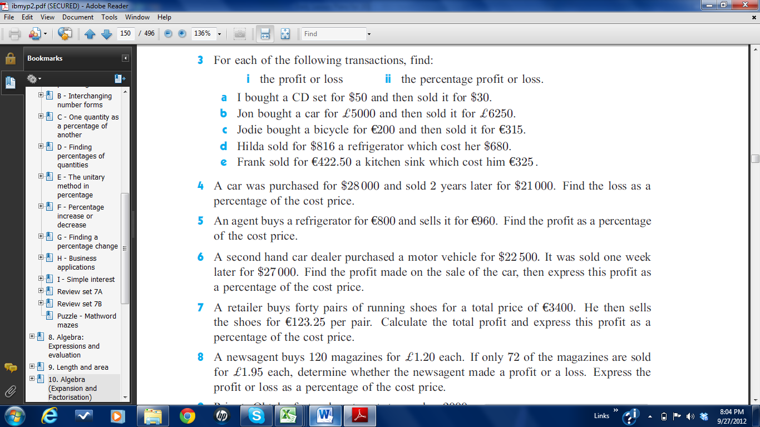

Please complete using the Simple Interest Formula:

