**Simple Interest**

In the financial world, banks operate by allowing businessmen, companies and people to invest their money

on the basis that interest will be added to the invested amount over a period of time at a particular rate on

interest. When this money is invested the bank adds interest to their invested money.

The difference between what it loaned and what is repaid is called interest. The sum of money lent is called

the Principal.

Hence the formula for finding the SI is:

$$I= \frac{PRT}{100}$$

***Complete the following problems, showing all work!***

1. $200 invested for 2 years at 5% p.a.
2. $280 invested for 6 years at 12% p.a.
3. What sum of money invested for 5 years at 10% p.a. gives $300 simple interest?
4. What sum of money earns $312 simple interest if invested for 8 years at 20%?
5. What annual rate of simple interest enables $500 to amount to $900 in 10 years?
6. Find the annual rate per cent that earns $200 simple interest when $1500 is invested for 5years.
7. What length of time is required if $500 amounts to $650 when invested for 3% p.a. simple interest?
8. What length of time is required if $1,250 amounts to $1,550 when invested for 5% p.a. simple interest?



## **Percent Problems:**

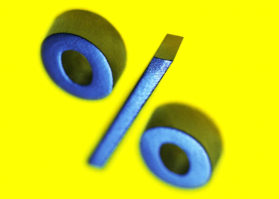*Copy and complete the following questions in your notebook. Show all work!*

1. $40\%$ of 15 cm
$80\% of 300g$

2. In a form of 30 pupils, 21 of them are boys.
   1. What percent are boys?
   2. What percent are girls?
3. In the 2012 season, the Chicago Cubs won 88 out of 162 games. What percent of the games did the Cubs win?
4. There are 250 pupils in my school and 35% are non – swimmers. How many pupils can swim?
5. Trevor and Michele’s restaurant bill comes to $35.50. They are planning to trip the waiter 20%. How much money should they leave for a tip?
6. An article costing $30 is sold at a profit of 25%. Find the selling price.
7. 6% sales tax on one 13 inch television which cost $4.50. What is the cost of the TV?
8. The bill for a back to school shopping outing is $5500 including a 25% discount. What was the cost of the times before the discount?
9. After a pay raise of 5%, John’s weekly pay is $4000. How much did he earn before the raise?

