HILLEL ACADEMY HIGH
MATHEMATICS DEPARTMENT
SEQUENCES AND SERIES

NAME: ______________________________________ DATE: _____________
Arithmetic Sequences and Series:
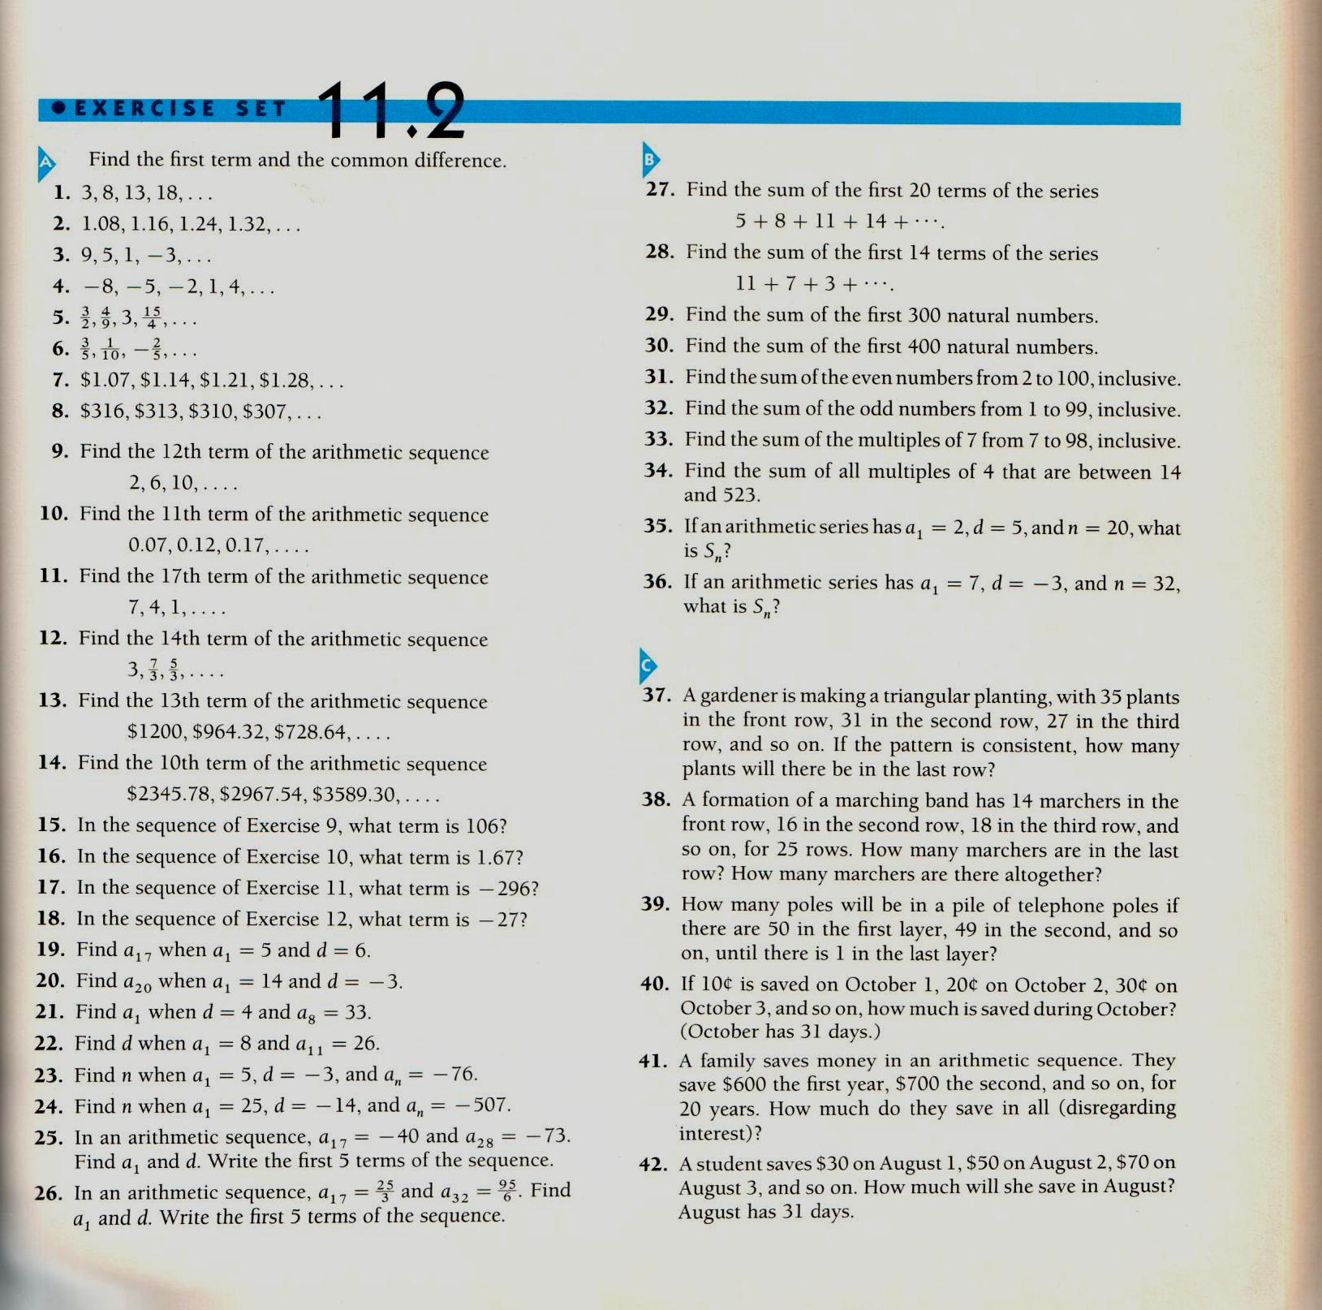

Geometric Sequences and Series:
